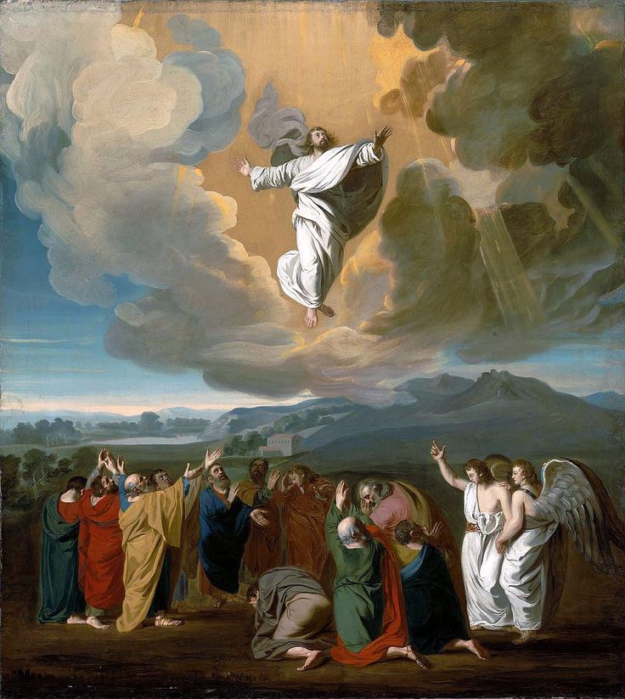
HOLYSPIRIT ON TOP OF DISCIPLES

